2026 SOUTHWEST PA CHAMPIONSHIP SHOW
JULY 11, 2026 JUDGE: JOE NASH
LYNDONVILLE, NEW YORK 9:30a.m.
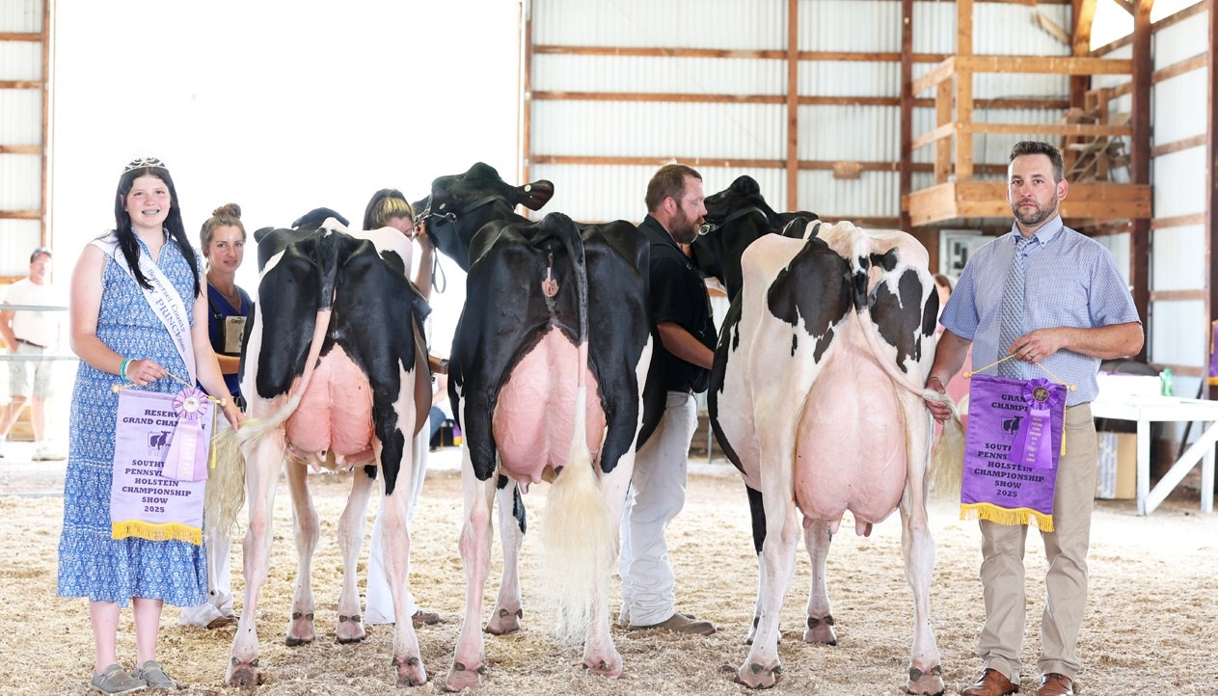
2025 SOUTHWEST PA CHAMPIONSHIP SHOW
Grand: McWilliams Damion Grace (Owned by: Sam McWilliams) Reserve: Milksource Americana-ET
(Owned by: Genetics Link)

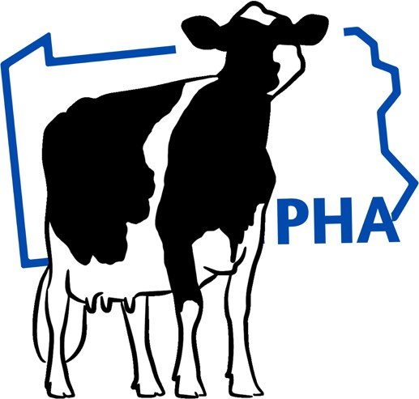
Somerset County Fairgrounds 7842 Mt. Davis Road Meyersdale, PA 15552
Showmanship July 10, 2026
Judge: Emory Bewley
6:00p.m.

Southwest PA Championship Show

Holstein Show
Holstein Show

Class 1 - Spring Heifer Calf (Born 03/01/26-05/31/26) (13 Entries)

JR Open


3
11

002 - Pennwood Jerry Lewis Radon
Tattoo/Herd Number/RFID: 9595 Registration Number: 840003300557702 Sire: Ladys Lambda Jerry Lewis-ET Dam: Welsh-Edge Unix Roe Radiant Breeder: Glenn H. Stoltzfus Bred & Owned: Yes Junior Entry: Yes

03/18/26

Madison P. Stoltzfus
All- Glo Berlin, PA


9
004 - AI-N-Tine Diesel Rain
Tattoo/Herd Number/RFID: 103 Registration Number: 840003288827880
Sire: Duckett Diesel-ET Dam: AI-N-Tine Analyst Ring-Red
Breeder: Allen Lehman
03/08/26
Natalie Petenbrink
AINTine Garrett, PA

101 - Ms BRX Caughtup In Vegas-ET
Tattoo/Herd Number/RFID: 840003298633126
1
Registration Number: 840003298633126 Sire: D2 Summerfest Caughtup-ET
Dam: Duckett Warrior Vero-ET Breeder: The Braxton Company
Bred & Owned: Yes

03/07/26

Sam Mcwilliams and Katie
Darnell
The Braxton Company
Salvisa, KY


2
10
005 - Hoo-Vale Warrior Beauty-ET
Tattoo/Herd Number/RFID: 3090 Registration Number: 840003306479347 Sire: Mr Blondin Warrior-Red-ET Dam: MD-Maple-Lawn Bailey-ET
Breeder: Jason L. Hoover Bred & Owned: Yes Junior Entry: Yes
Junior Bred&Owned: Yes
03/04/26
Jason Hoover
Hoo-vale Patton, PA

054 - Ms McWilliams Majr Uzzo-ET

Tattoo/Herd Number/RFID: 84000323437932
5
Registration Number: 84000323437932 Sire: Robella Major Dam: Duckett Impression Lily Breeder: Sam McWilliams Bred & Owned: Yes

03/04/26

Sam Mcwilliams Mcwilliams Farm Somerset, PA


7
006 - AII-Glo Alpha Twix
Tattoo/Herd Number/RFID: 602 Registration Number: 840003327683623
Sire: Blondin Alpha-ET Dam: Cantata War Tanzania-Red-ET
Breeder: Harper Miller Bred & Owned: Yes
03/03/26
Harper Miller
AII-Glo
Friedens, PA

007 - Klinedell Major Diva-ET
Tattoo/Herd Number/RFID: 840003278118175
6
Registration Number: 840003278118175 Sire: Robella Major
Dam: Oakfield Goldwyn Daisy-ET Breeder: Klinedell Farms

03/03/26

Paige Spory
Walnutdale Farm
Boswell, PA


3
031 - McWilliams C Up Again-ET
Tattoo/Herd Number/RFID: 840003323437931
Registration Number: 840003323437931 Sire: Farnear Architect-ET
Dam: M-Riverview Gold Chip Andie Breeder: Katie A McWilliams
Bred & Owned: Yes
03/03/26
Katie Mcwilliams
Mcwilliams Farm Somerset, PA

008 - McWilliams Ener Freedom-ET
Tattoo/Herd Number/RFID: 840003323437930
2
Registration Number: 840003323437930 Sire: Blondin Energy-ET
Dam: McWilliams Goldchip Faster Breeder: Sam R. McWilliams

03/02/26

Flynn and Stryder Miller
Arkenstone Farmstead LLC
Boswell, PA

13
009 - Pennwood Heist Krownjewel
Tattoo/Herd Number/RFID: 9573 Registration Number: 840003300557680
Sire: Genosource Heist-ET Dam: Pennwood Lionel Krystalyn
Breeder: Collin L. Stoltzfus
03/02/26
Emalyne Rosenbaum
Rosetree Acres Stoystown, PA

010 - AI-N-Tine Diesel Runaway

Tattoo/Herd Number/RFID: 9572 Registration Number: 840003300557679
12
Sire: Duckett Diesel-ET Dam: AI-N-Tine Rare EyeCandy
Breeder: Allen Lehman

03/01/26

Natalie Petenbrink
AINTine Garrett, PA


8
011 - Scenic-Hill Hazzle Kinder
Tattoo/Herd Number/RFID: 3085 Registration Number: 840003306479342
Sire: AOT Pazzle Hazzle-ET Dam: Scenic-Hill Analyst Kit-Kat
Breeder: Ashley M. Hoover Bred & Owned: Yes
03/01/26
Ashley Hoover
Hoo-vale Patton, PA

012 - PCH Alligator Jerky-ET
1

Tattoo/Herd Number/RFID: 3 Registration Number: 840003331266104
4
Sire: Stantons Alligator-ET Dam: Peace&Plenty Dim Jubie49-ET
Breeder: Matt Hawbaker Junior Entry: Yes

03/01/26
Claire Stoltzfus Pennwood Farms Manheim, PA

Southwest PA Championship Show Holstein Show

Class 2 - Winter Heifer Calf (Born 12/01/25-02/29/26)

(11 Entries)

JR Open
4
9

013 - Laspada Snoop Eggy
Tattoo/Herd Number/RFID: 5084 Registration Number: 840003298617111
Sire: Kings-Ransom Snoop-ET Dam: Laspada Deluxe 5064
Breeder: Michael LaSpada Junior Entry: Yes

01/15/26

Bristol Lyle Highland-H Brockway, PA

5
10
014 - Bervalon Gold Chip Tundra
Tattoo/Herd Number/RFID: 217 Registration Number: 840003320732426
Sire: Mr Chassity Gold Chip-ET Dam: Bervalon Neon Thrill
Breeder: Josie A Smiley Bred & Owned: Yes Junior Entry: Yes
Junior Bred&Owned: Yes
01/01/26
Josie Smiley
Bervalon Berlin, PA

015 - Pennwood Jinx Lil Skippy
Tattoo/Herd Number/RFID: 9490 Registration Number: 840003300557440 Sire: Mr Duckett Lambda Jinx-ET Dam: Pennwood Nashville Lil Miss Breeder: Kaitlyn M Stoltzfus Bred & Owned: Yes
8

12/29/25

Kaitlyn M. Stoltzfus
Pennwood Farms
Berlin, PA


3
7
016 - Bervalon Eye Candy Belair
Tattoo/Herd Number/RFID: 213 Registration Number: 840003320732422
Sire: MB-Lucklady Eye Candy-ET Dam: Bervalon Mayfield Barney
Breeder: Jane A Smiley Bred & Owned: Yes Junior Entry: Yes
12/15/25
Josie Smiley
Bervalon Berlin, PA

017 - Bervalon Hast Blueberry- Red

Tattoo/Herd Number/RFID: 840003293738559
3
2
Registration Number: 840003320732420 Sire: Siemers R Hastoric-Red-ET
Dam: Bervalon Appleway Bella-Red Breeder: Jeffery A. Smiley
Bred & Owned: Yes Junior Entry: Yes

12/09/25

Megan Smiley
Bervalon Farms
Berlin, PA

4
018 - Pennwood JrryLewis TiaMerry
Tattoo/Herd Number/RFID: 9473 Registration Number: 840003300557423
Sire: Ladys Lambda Jerry Lewis-ET Dam: Pennwood Doc TiaMaria
Breeder: Elizabeth M Stoltzfus Bred & Owned: Yes
12/08/25
Elizabeth Stoltzfus and Tylor
Smith
Pennwood Farms
Berlin, PA

019 - Lake-Effect Dir JustAPearl

Tattoo/Herd Number/RFID: 9471 Registration Number: 840003300557421
5
Sire: Blondin Direct-ET Dam: Lake-Effect JustANatural-ET
Breeder: Jeffery & Gayle Benedict

12/07/25

Elizabeth Stoltzfus
Pennwood Farms
Berlin, PA


6
020 - AII-Glo Analyst Slinky
Tattoo/Herd Number/RFID: 590 Registration Number: 840003301017964 Sire: Mr Affection Analyst-Red-ET Dam: Oakfield Merlin Savor-ET
Breeder: Kevin W & Janna Faith Miller Bred & Owned: Yes
12/06/25
Harper Miller
AII-Glo
Friedens, PA

021 - Sasow Allen Lowa
Tattoo/Herd Number/RFID: 840003331521871
11
6
Registration Number: 840003331521871 Sire: Magor Boliva Allen-ET Dam: Sasow Luster Lulu Breeder: Sara Maust Bred & Owned: Yes Junior Entry: Yes Junior Bred&Owned: Yes

12/03/25

Sara Maust
Meyersdale ,Pa., PA


1
022 - Genosource Cawt Mjr Heat-ET
Tattoo/Herd Number/RFID: 22492
Registration Number: 840003319404548 Sire: Robella Major
Dam: Ms Gs Caught Some Heat-ET Breeder: Genosource
12/03/25
Russ-jan Holsteins
Diamond K Holsteins New enterprise, PA

023 - McWilliams Alpha Danielle

Tattoo/Herd Number/RFID: 840003323437927
2
1
Registration Number: 840003323437927 Sire: Blondin Alpha-ET Dam: Riverdown Lambda Danika-ET Breeder: Sam McWilliams Junior Entry: Yes

12/01/25

Ainsely Kozuch Mcwilliams Farm Somerset, PA

Southwest PA Championship Show

Class 3 - Fall Heifer Calf (Born 09/01/25-11/30/25)
Holstein Show

(8 Entries)

JR Open
8

024 - Sonnen Dropbox Kiwi
Tattoo/Herd Number/RFID: 9452 Registration Number: 840003300557402 Sire: Kings-Ransom Dropbox-ET Dam: Sonnen Lu-Tenant U Kissable Breeder: Adam & Lisa Sonnen

11/12/25

Greyson Baker Ott Pennwood Farms Manheim, PA

3
025 - McWilliams E Alabama
Tattoo/Herd Number/RFID: 5948 Registration Number: 84000373057483
Sire: Blondin Energy-ET Dam: M-Riverview Gold Chip Andie
Breeder: Katie McWilliams Bred & Owned: Yes
09/27/25
Katie Mcwilliams
Mcwilliams Farm Somerset, PA

026 - Pennwood Haniel Giselle
Tattoo/Herd Number/RFID: 9409 Registration Number: 840003300557609
7
5
Sire: Siemers Haniel-P-ET Dam: Pennwood Mitchell Giddy
Breeder: Mason 0. Stoltzfus Bred & Owned: Yes Junior Entry: Yes
Junior Bred&Owned: Yes

09/20/25

Mason 0. Stoltzfus
All- Glo Berlin, PA

1
1
027 - Oakfield Major Junie-ET
Tattoo/Herd Number/RFID: 5 Registration Number: 840003307810634
Sire: Robella Major Dam: Pierstein Master Juno-ET
Breeder: Oakfield Corners Dairy Show Cattle Junior Entry: Yes
09/17/25
Raegan Wolfe
Wolfepack Holsteins
Perkasie, PA

028 - AII-Glo Lombardi Dynamit
Tattoo/Herd Number/RFID: 585 Registration Number: 840003301017959
6
4
Sire: Townlineacre DL Lombardi-ET Dam: AII-Glo Sidekick Disney
Breeder: Kevin W & Janna Faith Miller Junior Entry: Yes

09/17/25

Mackenzie Rosenbaum
Rosetree Acres Stoystown, PA

2
2
029 - Pennwood Dropbox Dabai
Tattoo/Herd Number/RFID: 9402 Registration Number: 840003300557602 Sire: Kings-Ransom Dropbox-ET Dam: Pennwood Hancock Denmark Breeder: Cara Stoltzfus Bred & Owned: Yes Junior Entry: Yes
Junior Bred&Owned: Yes
09/13/25
Cara Stoltzfus
Pennwood Farms Manheim, PA

030 - Pennwood Hank lmADancer
Tattoo/Herd Number/RFID: 9392 Registration Number: 840003300557592 Sire: HigherRansom Hank Aaron-ET Dam: Pennwood Tattoo lmAChick Breeder: Sara Lynn Stoltzfus Bred & Owned: Yes Junior Entry: Yes
4
3
Junior Bred&Owned: Yes

09/06/25

Sara L. Stoltzfus
Pennwood Farms
Berlin, PA

5
032 - Perfectouch Beemer Totem-ET
Tattoo/Herd Number/RFID: 840003278118169
Registration Number: 840003278118169 Sire: Pol Butte MC Beemer-ET
Dam: My-Style Alliance Tiki Breeder: Paige Friedline Bred & Owned: Yes
09/01/25
Paige Spory
Walnutdale Farm
Boswell, PA

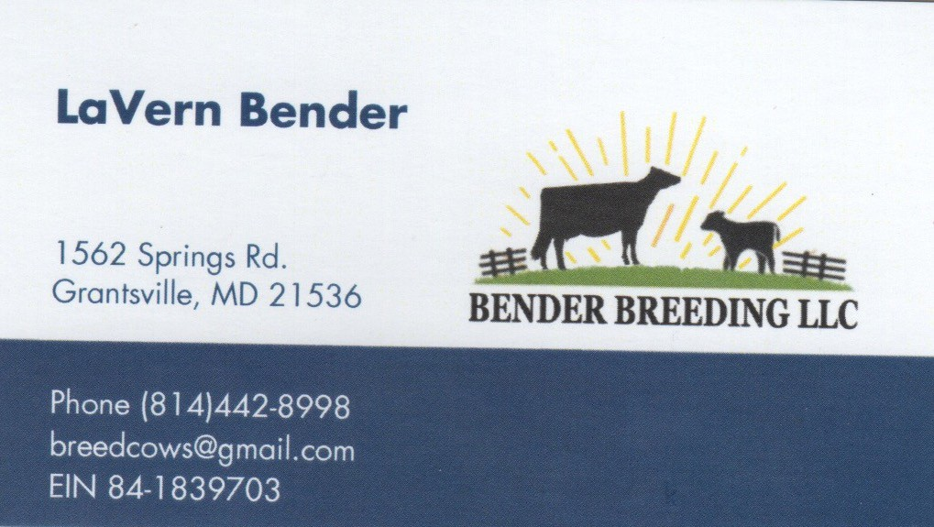
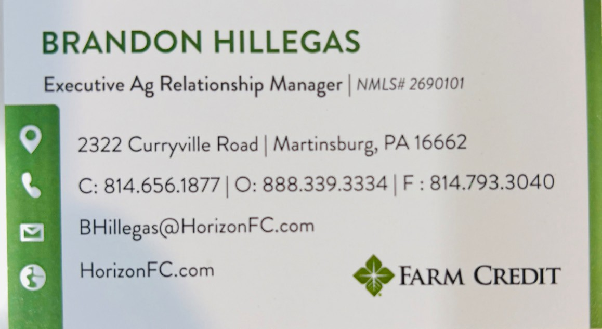

Southwest PA Championship Show

Class 4 - Summer Yearling Heifer (Born 06/01/25-08/31/25)
Holstein Show
(9 Entries)

JR Open

4

033 - AII-Glo Hancock Millie
Tattoo/Herd Number/RFID: 9353 Registration Number: 840003300557553
Sire: Siemers Doc Hancock Dam: AII-Glo WL Sidekick Mollie
Breeder: Justin and Ashley Kaufman Bred & Owned: Yes

07/17/25

Justin And Ashley Kaufman
All- Glo Berlin, PA

5
034 - Pennwood Hancock Tinder2
Tattoo/Herd Number/RFID: 9347 Registration Number: 840003300557547
Sire: Seimers Doc Hancock Dam: Pennwood Cinder Tinder
Breeder: Elizabeth M Stoltzfus Bred & Owned: Yes
07/12/25
Elizabeth Stoltzfus
Pennwood Farms
Berlin, PA

035 - DB&J Master Batman

Tattoo/Herd Number/RFID: 467 Registration Number: 840003279968241
3
Sire: Golden-Oaks Master-ET Dam: DB&J Kingboy Bubbles
Breeder: DB&J Holsteins LLC

06/30/25

Justin And Ashley Kaufman
All- Glo Berlin, PA

7
036 - Ms Link A Allure-Red-ET
Tattoo/Herd Number/RFID: 1193 Registration Number: 840003266227463
Sire: Farnear Architect-ET Dam: Kampy Alt Adeline-Red-ET
Breeder: Genetics link
06/26/25
Sam Mcwilliams
Mcwilliams Farm Somerset, PA

037 - Bervalon Tatoo Jazzy

Tattoo/Herd Number/RFID: 178 Registration Number: 840003291155173
6
1
Sire: Duckett Crush Tatoo-ET Dam: Bervalon Sanchez Jessie
Breeder: Jane Ann Smiley Bred & Owned: Yes Junior Entry: Yes

06/22/25

Josie Smiley
Bervalon Berlin, PA

1
038 - Ms Cabos Courage-ET
Tattoo/Herd Number/RFID: 1590 Registration Number: 840003266250369 Sire: Genosource Liquidcourage-ET Dam: R-E-W Moovin To Cabo-ET Breeder: Retso Holsteins,J & A Hippen, B & K Ziemba
06/17/25
Russ-jan Holsteins
Diamond K Holsteins New enterprise, PA

039 - AII-Glo Charles Looker
Tattoo/Herd Number/RFID: 574 Registration Number: 840003301017948
2
Sire: Boulet Charles-ET Dam: Quail-Ridge Warrior Liza
Breeder: Justin and Ashley Kaufman Bred & Owned: Yes

06/14/25

Justin And Ashley Kaufman
All- Glo Berlin, PA

9
040 - Cherry-H&S War Rosa-Red-ET
Tattoo/Herd Number/RFID: 840003278118252
Registration Number: 840003286146305 Sire: Mr Blondin Warrior-Red-ET
Dam: Cherry-Lor DBK Robin-Red-ET Breeder: Boop & Hembury
06/10/25
Paige Spory
Walnutdale Farm
Boswell, PA

041 - Bervalon Victor Troubadour
Tattoo/Herd Number/RFID: 176 Registration Number: 840003291155171
8
2
Sire: T-Triple-T Doorman Victor Dam: Bervalon Summer-P Taffy Breeder: Josie A Smiley Bred & Owned: Yes Junior Entry: Yes Junior Bred&Owned: Yes

Class 5 - Spring Yearling Heifer (Born 03/01/25-05/31/25)

042 - Oakfield Landslide-Red-ET

06/05/25

Josie Smiley
Bervalon Berlin, PA

(5 Entries)

Elizabeth and Kaitlyn Stoltzfus

Tattoo/Herd Number/RFID: 840003300557338
4
Registration Number: 840003300557338 Sire: Blondin Alpha-ET
Dam: Kevetta Daniel Lexi Breeder: Oakfield Corners Dairy Show Cattle
03/14/25 Pennwood Farms Berlin, PA

3
043 - McWilliams Mster Come Over
Tattoo/Herd Number/RFID: 5928 Registration Number: 840003273057463
Sire: Golden-Oaks Master-ET Dam: Highland-H Doorman Crispy
Breeder: Sam R. McWilliams Bred & Owned: Yes
03/12/25
Sam Mcwilliams
Highland-H Brockway, PA

100 - Braxco Alpha Velour
Tattoo/Herd Number/RFID: 840003298633119
1
Registration Number: 840003298633119 Sire: Blondin Alpha-ET Dam: Braxco Advancer Velour Breeder: The Braxton Company Bred & Owned: Yes

03/10/25

Sam Mcwilliams and Katie
Darnell
The Braxton Company
Salvisa, KY

2
044 - AII-Glo Sidekick Koffee
Tattoo/Herd Number/RFID: 9221 Registration Number: 840003300557328
Sire: Walnutlawn Sidekick Dam: AII-Glo Hanans Kaffiene
Breeder: Justin and Ashley Kaufman
03/08/25
Russ-jan Holsteins
Diamond K Holsteins New enterprise, PA

045 - Te-Ola-Land Pete Miriam
Tattoo/Herd Number/RFID: 160 Registration Number: 840003249943190
5
1
Sire: Straight-Pine Elevation Pete Dam: Te-Ola-Land Encore Mimi 2
Breeder: Terry Wayne Landis Bred & Owned: Yes Junior Entry: Yes

03/03/25
Sam Landis Hillside Farm Berlin, PA

Southwest PA Championship Show
Class 6 - Winter Yearling Heifer (Born 12/01/24-02/28/25)
Holstein Show
(9 Entries)

JR Open

4

046 - E-Lap Bullseye Priceless
Tattoo/Herd Number/RFID: 554 Registration Number: 840003288645695
Sire: MB-Luckylady Bullseye-ET Dam: E-Lap Hancock Paytam
Breeder: Elam Lapp

Sam Mcwilliams
02/21/25 Mcwilliams Farm Somerset, PA


3
048 - Pennwood Bullseye Miriam
Tattoo/Herd Number/RFID: 9169 Registration Number: 840003265812806
Sire: MB-Luckylady Bullseye-ET Dam: Ms Pennwood Demp Menthol-ET
Breeder: Donald and Joanne Stoltzfus Bred & Owned: Yes
Donald and Joanne Stoltzfus
01/11/25 All- Glo
Berlin, PA

049 - AII-Glo Luster-P Samwise

Tattoo/Herd Number/RFID: 548 Registration Number: 840003286146003
9
5
Sire: Cherry-Lilly Zip Luster-P-ET Dam: AII-Glo Dempsey Sparks
Breeder: Allen J. & Gloria J. Kaufman Junior Entry: Yes

Mackenzie Rosenbaum
12/25/24 Rosetree Acres Stoystown, PA


3
7
050 - AII-Glo Alpha Tinsel-Red-ET
Tattoo/Herd Number/RFID: 547 Registration Number: 840003286146002
Sire: Blondin Alpha-ET Dam: Cantata War Tanzania-Red-ET
Breeder: Kevin and Janna Miller Junior Entry: Yes
12/21/24
Lakin Friedline
Bervalon Berlin, PA

051 - Oakfield Hulu Amber-Red-ET

Tattoo/Herd Number/RFID: 2013 Registration Number: 840003288590307 Sire: Siemens Wolf Hulu 37006-ET Dam: Colganados D Avianca-Red-ET Breeder: Jonathan & Alicia Lamb
2

Russ-jan Holsteins
12/19/24 Diamond K Holsteins New enterprise, PA


2
5
052 - Pennwood Bullseye Pandora
Tattoo/Herd Number/RFID: 9147 Registration Number: 840003265812784
Sire: MB-Luckylady Bullseye-ET Dam: Pennwood Tatoo Prickle Breeder: Claire Stoltzfus Bred & Owned: Yes Junior Entry: Yes Junior Bred&Owned: Yes
12/15/24
Claire Stoltzfus
Pennwood Farms Manheim, PA

053 - Highland-H J Candy Cane-Red

Tattoo/Herd Number/RFID: 900 Registration Number: 840003131123596 Sire: Cycle McGucci Jordy-Red Dam: Highland-H Wrrior Crumb-Red Breeder: Christy A. Hindman Bred & Owned: Yes
6

Christy Hindman & Michael
12/13/24 Laspada
Highland-H Brockway, PA


1
1
055 - Pennwood Rompen Wrench
Tattoo/Herd Number/RFID: 840003265812780
Registration Number: 840003265812780
Sire: Trent-Way-JS Rompen-Red-ET Dam: Pennwood Tatoo Wreath
Breeder: Charles E. Stoltzfus Bred & Owned: Yes Junior Entry: Yes
Junior Bred&Owned: Yes
12/11/24
Charles E. Stoltzfus
Pennwood Farms
Berlin, PA

057 - Bo-Ann Actyl Peppermint-Red
4

Tattoo/Herd Number/RFID: 594 Registration Number: 840003281719307
8
Sire: Luck-E-Acetylene-Red-ET Dam: Bo-Ann Jordy Peyton-Red
Breeder: Robert & Judi A Hauck Junior Entry: Yes

Class 7 - Fall Yearling Heifer (09/01/24-11/30/24)

058 - Scenic-Hill Delta Koollatte
Tattoo/Herd Number/RFID: 2939 Registration Number: 840003287670263
2
Sire: Mr Mogul Delta 1427-ET Dam: Scenic-Hill Ashtag Koolwhip
Breeder: Ashley M. Hoover Bred & Owned: Yes

12/01/24

10/17/24

Jason Hoover
Hoo-vale Patton, PA

(2 Entries)

Ashley Hoover
Hoo-vale Patton, PA


1
059 - Pennwood Haniko Tribute2
Tattoo/Herd Number/RFID: 9054 Registration Number: 840003265812691
Sire: Siemers Lambda Haniko-ET Dam: Pennwood Windbrk Tribute-ET
Breeder: Elizabeth Stoltzfus Bred & Owned: Yes
09/01/24
Elizabeth Stoltzfus
Pennwood Farms
Berlin, PA

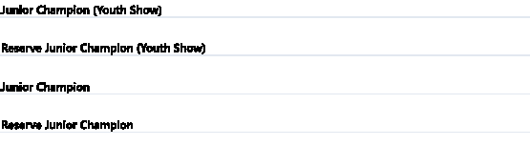
Oakfield Major Junie-ET- Raegan Wolfe
Pennwood Rompen Wrench- Charles Stoltzfus
Honorable Mention: McWilliams Alpha Danielle- Ainsely Kozuch
Ms BRX Caughtup In Vegas-ET- Sam McWilliams and Katie Darnell
Oakfield Major Junie-ET- Raegan Wolfe
Honorable Mention: Pennwood Rompen Wrench- Charles Stoltzfus

Class 1 - Junior Best Three Females


SCRATCH
(5 Entries)

Josie Smiley
Bervalon Berlin, PA


4 061
Harper Miller
All-Gia Friedens, PA


062
1

Penwood Farm
Pennwood Farms
Berlin, PA


3 063
Justin And Ashley Kaufman
All- Gia Berlin, PA


102
2

Mcwilliams Farm
Mcwilliams Farm Somerset, PA


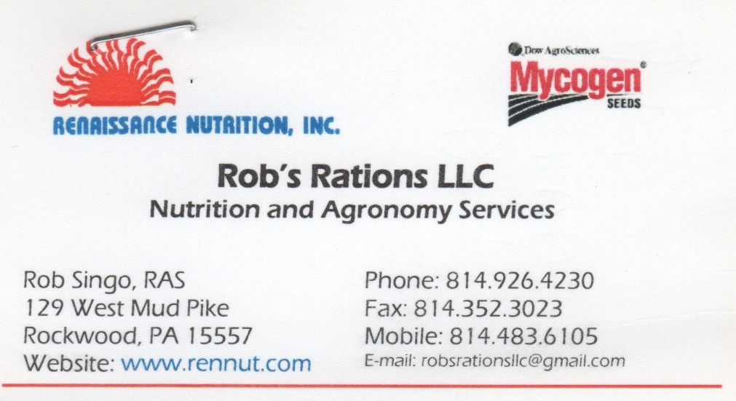


Southwest PA Championship Show

Class 8 - Summer Junior 2 Year Old (Born 06/01/24 to 08/31/24)
Holstein Show

(2 Entries)


JR Open
1
2

065 - Pennwood Hancock Sperry
Tattoo/Herd Number/RFID: 8988 Registration Number: 840003265812625
Sire: Siemers Doc Hancock Dam: Pennwood Sidekick Splash
Breeder: Dwight & Lindsay Stoltzfus Bred & Owned: Yes Junior Entry: Yes

06/11/24

Cara Stoltzfus Pennwood Farms Manheim, PA


1
067 - Blondin Lambda Bravo-ET
Tattoo/Herd Number/RFID: 2051 Registration Number: 121802051
Sire: Farnear Delta-Lambda-ET Dam: MD-West-View Brandy U Brass
Breeder: Ferme Blondin & Blondin Sires
06/03/24
Russ-jan Holsteins
Diamond K Holsteins New enterprise, PA

Class 9 - Spring Junior 2 Year Old (Born 03/01/24-05/31/24)

068 - Ms Bratcher-Vu DL Barbie-ET

Tattoo/Herd Number/RFID: 1383 Registration Number: 840003285580667 Sire: Farnear Delta-Lambda-ET Dam: Gold-Barbara Summerbreez-ET Breeder: T Bratcher, H&H Spoonamore & A Carrier
1

04/03/24
(5 Entries)

Genetics Link Mcwilliams Farm Somerset, PA


2
069 - Pennwood Partake Partido-TW
Tattoo/Herd Number/RFID: 8904 Registration Number: 840003265812541
3 Sire: Siemers H Partake 35318-ET Dam: Pennwood Sidekick Pop Fly
03/21/24
Breeder: Claire Stoltzfus Bred & Owned: Yes Junior Entry: Yes
Junior Bred&Owned: Yes
Claire Stoltzfus
Pennwood Farms Manheim, PA

070 - Pennwood Jagger Little Lady

Tattoo/Herd Number/RFID: 8903 Registration Number: 840003265812540
2
1
Sire: Peak Jagger-ET Dam: Pennwood Handshake Lady
Breeder: Sara Lynn Stoltzfus Bred & Owned: Yes Junior Entry: Yes
Junior Bred&Owned: Yes

03/19/24

Sara L. Stoltzfus
Pennwood Farms
Berlin, PA


3
4
071 - Grace-Leigh W Slinky-Red-ET
Tattoo/Herd Number/RFID: 1006 Registration Number: 840003263220556
Sire: Mr Blondin Warrior-Red-ET Dam: Redtag Destry Sneezy-Red-ET
Breeder: Grace-Leigh Holsteins Junior Entry: Yes
03/05/24
Lydia Couch
Lakevue HUNTINGDON, PA

064 - McWilliams Tango Whitney

Tattoo/Herd Number/RFID: 840003273057425
5
Registration Number: 840003273057425 Sire: Golden-Oaks Tango-Red-ET
Dam: Woodlawn Crushabull Whip Breeder: Katie McWilliams
Bred & Owned: Yes

Class 10 - Winter Senior 2 Year Old (Born 12/01/23 - 02/28/24)

072 - Pennwood Has It All Darkest

Tattoo/Herd Number/RFID: 840003265812470
1
Registration Number: 840003265812470 Sire: Deckett Pfct Has It All-ET
Dam: Pennwood Sidekick Darker Breeder: Elizabeth M. Stoltzfus
Bred & Owned: Yes

03/02/24

01/12/24

Katie Mcwilliams
Mcwilliams Farm Somerset, PA

(2 Entries)

Elizabeth Stoltzfus
Pennwood Farms
Berlin, PA


2
073 - McWilliams EC Adreniline-ET
Tattoo/Herd Number/RFID: 5874 Registration Number: 840003273057409
Sire: MB-LuckyLady Eye Candy-ET Dam: M-Riverview Gold Chip Andie
Breeder: Katie McWilliams Bred & Owned: Yes
12/04/23
Katie Mcwilliams
Mcwilliams Farm Somerset, PA



Southwest PA Championship Show

Class 11 - Fall Senior 2 Year Old (Born 09/01/23 - 11/30/23)
Holstein Show
(3 Entries)

JR Open

2

075 - Lake-Effect Just A Natural-ET
Tattoo/Herd Number/RFID: 52 Registration Number: 840003272933387
Sire: Woodcrest King Doc Dam: Lake-Effect JustADream-Red
Breeder: Jeffrey & Gayle Benedict

10/13/23

Elizabeth Stoltzfus
Pennwood Farms
Berlin, PA


3
076 - McWilliams Alpha Shania
Tattoo/Herd Number/RFID: 5863 Registration Number: 840003273057398
Sire: Blondin Alpha-ET Dam: McWilliams Bubbagump Shrimp
Breeder: Clyde and Charlene McWilliams Bred & Owned: Yes
09/16/23
Clyde and Charlene
Mcwilliams
Mcwilliams Farm Somerset, PA

- J-Folts Al Homegirl
Tattoo/Herd Number/RFID: 840003268714589
1
Registration Number: 840003268714589 Sire: Stantons Alligator-ET
Dam: J-Folts Awesome Honu-ET Breeder: Isaac Folts

Class 12 - Junior 3 Year Old (Born 03/01/23-08/31/23)

- Pennwood Harrisena Salty

Tattoo/Herd Number/RFID: 8592 Registration Number: 840003263223259
2
1
Sire: CookieCutter Harrisenna Dam: Pennwood Copyright Sally
Breeder: Duane N. & Andrea Stoltzfus Junior Entry: Yes

09/06/23

03/19/23
Genetics Link Mcwilliams Farm Somerset, PA

(3 Entries)

Charles E. Stoltzfus
Pennwood Farms
Berlin, PA


3
079 - McWilliams Energy Wiz Kalif
Tattoo/Herd Number/RFID: 5850 Registration Number: 840003273057385
Sire: Blondin Energy-ET Dam: McWilliams Dan Wynter
Breeder: Clyde and Charlene McWilliams
03/09/23
Russ-jan Holsteins
Diamond K Holsteins New enterprise, PA

080 - McWilliams Thunder Brazil

Tattoo/Herd Number/RFID: 840003247317384
1
Registration Number: 840003247317384 Sire: Blondin Thunderstorm
Dam: Oakfield Gold Beckham- ET Breeder: Sam R. McWilliams
Bred & Owned: Yes

Class 13 - Senior 3 Year Old (Born 09/01/22-02/28/23)

082 - All- Glo D Lambda Myla- ET

Tattoo/Herd Number/RFID: 8513 Registration Number: 840003263223180
2
1
Sire: Farnear Delta- Lambda- ET Dam: All- Glo Sidekick Mika
Breeder: Justin and Ashley Kaufman Bred & Owned: Yes Junior Entry: Yes

03/03/23

12/22/22

Sam Mcwilliams Mcwilliams Farm Somerset, PA

(4 Entries)

Avery Kaufman
All- Glo Berlin, PA

4
083 - C-Cove Doc Tulsa
Tattoo/Herd Number/RFID: 615 Registration Number: 840003268453898
Sire: Woodcrest King Doc Dam: C-Cove Sidekick Tattoo
Breeder: Cessna Bros.
12/17/22
Russ-jan Holsteins
Diamond K Holsteins New enterprise, PA

084 - AII-Glo Hanans Kaffiene
Tattoo/Herd Number/RFID: 8503 Registration Number: 840003263223170 Sire: Siemers Exe Hanans 31753-ET Dam: AII-Glo Gld Chip Karamel-ET Breeder: Justin and Ashley Kaufman Bred & Owned: Yes
1

12/11/22

Justin And Ashley Kaufman
All- Glo Berlin, PA

3
085 - Kampy Alt Adeline-Red-ET
Tattoo/Herd Number/RFID: 840003242385012
Registration Number: 840003242385012 Sire: Farnear Altitude-Red-ET
Dam: HiIrose AvaInch Addy-Red-ET Breeder: Derrick S Kamphuis
12/03/22
Genetics Link
Mcwilliams Farm Somerset, PA
Intermediate Champion (Youth Show) Pennwood Jagger Little Lady- Sara Stoltzfus

Reserve Intermediate Champion (Youth Show) All-Glo D Lambda Myla-ET- Avery Kaufman

Honorable Mention: Pennwood Partake Partido-TW-
Claire Stoltzfus

Intermediate Champion

Ms Bratcher-Vu DL Barbie-ET- Genetics Link
Pennwood Jagger Little Lady- Sara Stoltzfus

Reserve Intermediate Champion

Honorable Mention: All-Glo Hanans Kaffiene Justin & Ashley Kaufman

Southwest PA Championship Show

Class 14 - 4-year-old (Born 09/01/21-08/31/22)
Holstein Show

(3 Entries)


JR Open
2

086 - Pennwood Cheif Ravioli
Tattoo/Herd Number/RFID: 8348 Registration Number: 840003244598038
Sire: Stantons Chief-ET Dam: Muranda Impress Ravelynn-ET
Breeder: Elizabeth M. Stoltzfus Bred & Owned: Yes

06/30/22

Elizabeth Stoltzfus
Pennwood Farms
Berlin, PA

1
087 - Harvue Hancock Fan
Tattoo/Herd Number/RFID: 840003250268088
Registration Number: 840003250268088 Sire: Siemers Doc Hancock
Dam: Harvue Tatoo Fant Breeder: Matthew Hardesty
04/09/22
Russ-jan Holsteins
Diamond K Holsteins New enterprise, PA

- Bervalon Neon Tilly
Tattoo/Herd Number/RFID: 994 Registration Number: 840003238922265
3
1
Sire: Shuh-vu Undenied Neon ET Dam: Bervalon Brawler Tally Breeder: Jonathan and Jennifer Smiley Bred & Owned: Yes Junior Entry: Yes

Class 15 - 5-year-old (Born 09/01/20-08/31/21)

- Whiteleather Solo 4626

Josie Smiley
09/16/21 Bervalon
Berlin, PA

(2 Entries)

Sam Mcwilliams

Tattoo/Herd Number/RFID: 840003241542836
1
Registration Number: 840003241542836 Sire: Whiteleather Solo 3737-ET
Dam: Whiteleather Reign 3894-TW Breeder: Whiteleather Holsteins

08/17/21
Mcwilliams Farm Somerset, PA


1
2
091 - Bervalon Redeye Bubbles
Tattoo/Herd Number/RFID: 840003255675869
Registration Number: 840003238922248 Sire: Vogue Redeye P-Red
Dam: Bervalon Summer-P Birch Breeder: Joel K. Smiley
Bred & Owned: Yes Junior Entry: Yes
07/16/21
Megan Smiley
Bervalon Farms
Berlin, PA

Class 16 - Aged Cow (Born Prior to 08/31/20)

092 - McWilliams Bubbagump Shrimp

Tattoo/Herd Number/RFID: 840003202765575
2
Registration Number: 840003202765575 Sire: Mr Corona Bubba-ET Dam: McWilliams Capital Z Susan Breeder: Charlene Mcwilliams Bred & Owned: Yes

06/03/19
(2 Entries)

Clyde and Charlene
Mcwilliams Mcwilliams Farm Somerset, PA

1
093 - Pennwood Sidekick Amber
Tattoo/Herd Number/RFID: 840003202558763
Registration Number: 840003202558763 Sire: Walnutlawn Sidekick
Dam: Pennwood Aftershock Annique Breeder: Pennwood Farm
Bred & Owned: Yes
09/13/18
Penwood Farm
Pennwood Farms
Berlin, PA

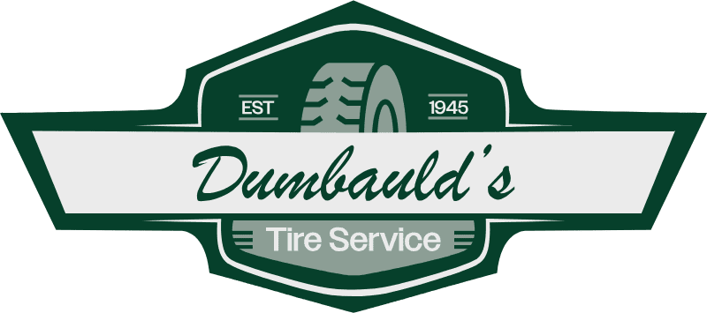
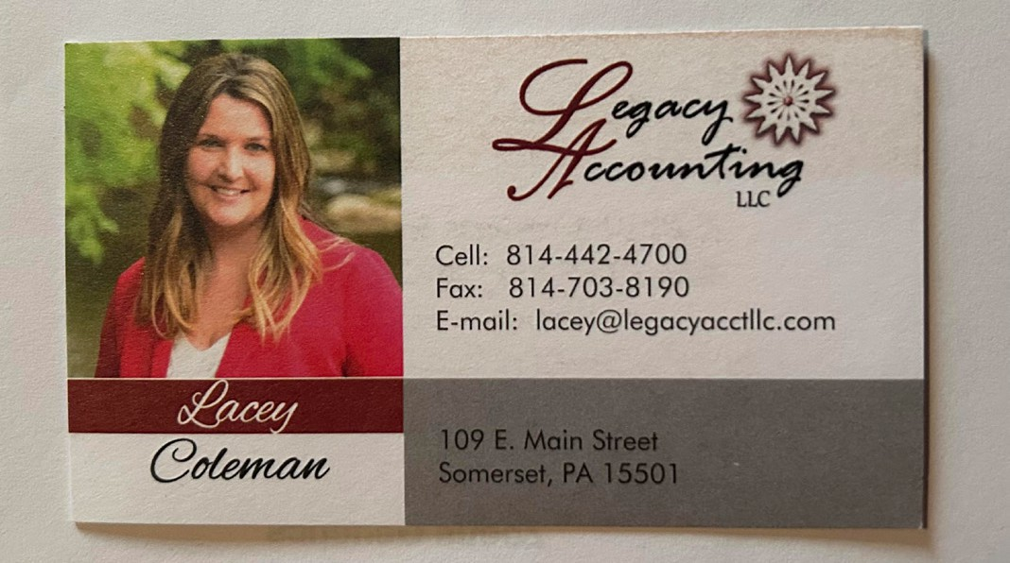

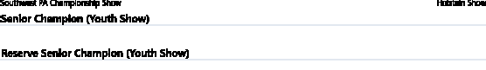
Bervalon Redeye Bubbles- Megan Smiley Bervalon Neon Tilly- Josie Smiley
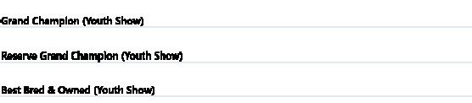

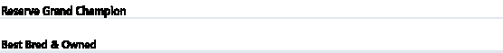
Bervalon Redeye Bubbles- Megan Smiley
Pennwood Jagger Little Lady- Sara Stoltzfus
Pennwood Jagger Little Lady- Sara Stoltzfus
Harvue Hancock Fan- Russ- Jan Holsteins
Whiteleather Solo 4626- Sam McWilliams
Honorable Mention: Pennwood Sidekick Amber- Pennwood Farm
Harvue Hancock Fan- Russ- Jan Holsteins
Ms Bratcher-Vu DL Barbie-ET- Genetics Link
Pennwood Sidekick Amber- Pennwood Farm

Premier Breeder & Exhibitor : Pennwood Farm
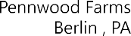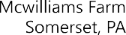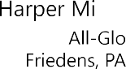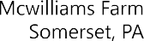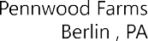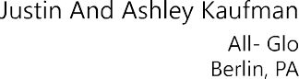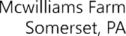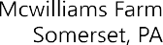
1
2
SCRATCH
1
SCRATCH
SCRATCH
1
2

